Assignment 6

## Afia Fahmida Rahman

17101240

1. Work break down structure:
2. Analysis

* Collect documents from the customers
* Communicate; Interview Stakeholders
* Requirements Collection
* Designing System Requirements Specification

1. Design

* Interface Design
* Database
* Application Interface
* Develop Architectural Model

1. Coding

* Coding as per the design
* Coding each of the aspects, ie. User interface, database, etc
* Coding as per the architectural model, eg. Layered architecture

1. Testing

* Eg. Unit testing using Junit
* Getting customers to test the product by using them

1. Duration

An estimate of 35 days has been thought to be required to make the initial program. The breakdown of which tasks are to be done when are shown in the following Gantt chart:

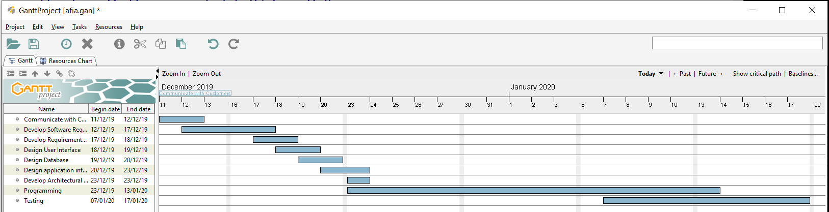

1. Resources

In this case, our resources for the document collection part are specialists who are meant to write Requirement documents and requirement analysis only.

For design, we shall hire design experts and for coding, we shall hire software engineers.

For testing, we need software testers with certification.